CHAPTER ONE
INTRODUCTION

1.1 Background of Study

1.1.1 The Growing Challenge of Document Fraud in the Digital Age
The integrity of documentary evidence underpins virtually every significant transaction, credential, and institutional process in contemporary society. From the academic transcripts that determine university admissions, to the employment contracts that govern professional relationships, to the financial statements that underpin business decisions, documents serve as the authoritative medium through which institutions and individuals establish facts, confer rights, and discharge obligations. The authenticity of these documents is therefore not merely a matter of administrative procedure but a prerequisite for the functioning of organized social, economic, and legal life.
Document fraud the deliberate creation, alteration, or use of falsified documents with intent to deceive is not a new phenomenon. Historically, forgery required specialist skills: the ability to replicate watermarks, official seals, and handwriting styles that served as physical authentication markers. The analogue nature of these security features provided a natural barrier against mass forgery, limiting document fraud to relatively skilled and well-resourced actors. The transition from analogue to digital documentation systems has fundamentally altered this landscape. The widespread adoption of PDF documents, image-format certificates, and digitally submitted credentials has displaced physical authentication mechanisms without establishing comparably robust digital alternatives in mainstream organizational workflows (Casey, 2011).
The democratization of powerful graphic design tools has simultaneously lowered the technical barrier to document manipulation to an unprecedented degree. Software such as Adobe Acrobat, Adobe Photoshop, GIMP, Canva, and Microsoft Word all widely available at low or no cost enables users with minimal technical expertise to modify dates, names, grades, signatures, and official stamps on digital documents with a level of visual fidelity that challenges human inspection (Farid, 2016). The emergence of generative artificial intelligence tools capable of synthesizing realistic document content and replicating institutional letterheads has further intensified these risks. According to the Association of Certified Fraud Examiners (ACFE, 2022), document fraud contributes to organizational losses estimated at five percent of annual revenues globally, amounting to trillions of dollars in aggregate economic damage.

1.1.2 The Scale and Impact of Document Fraud Across Sectors
The consequences of document fraud are distributed across multiple sectors of society, each bearing distinct vulnerabilities and impacts. In the employment sector, fraudulent academic credentials and professional certifications represent one of the most pervasive forms of institutional deception. A global survey conducted by HireRight (2020) found that approximately eighty-four percent of employers had detected at least one misrepresentation on a candidate's application or resume, with forged degree certificates, fabricated transcripts, and counterfeit professional licences among the most commonly identified fraudulent documents.
Table 1.1: Impact of Document Fraud Across Key Sectors
Sector | Primary Document Types Affected | Annual Estimated Loss | Key Consequence
Employment | Degree certificates, transcripts, professional licences | USD 600 billion+ | Unqualified personnel in critical roles
Healthcare | Medical licences, prescriptions, insurance claims | USD 80 billion (US only) | Patient safety risk, insurance fraud
Legal/Financial | Contracts, wills, financial statements, invoices | USD 200 billion+ | Contract disputes, financial fraud
Education | Transcripts, recommendation letters, ID documents | Not fully quantified | Fraudulent admissions, degree inflation
Immigration | Passports, visas, birth certificates | USD 5 billion+ | Illegal border crossings, identity fraud
Source: ACFE (2022); Coalition Against Insurance Fraud (2022); World Bank (2022)
In the academic domain, the global trade in fraudulent credentials has grown into a multi-billion-dollar illicit industry. Degree mills and diploma mills operate openly in numerous jurisdictions, issuing fraudulent qualifications that are visually indistinguishable from legitimate degrees (Eaton, 2020). In the healthcare sector, forged medical licences and fraudulent prescriptions create direct public safety risks. In legal and financial contexts, the manipulation of contracts, wills, property deeds, and financial statements enables fraud schemes that undermine the integrity of commercial transactions and legal proceedings.
The financial technology sector has identified document fraud particularly the manipulation of bank statements, payslips, and identity documents submitted in support of digital loan applications as a growing challenge for know-your-customer (KYC) and anti-money laundering (AML) compliance processes (Accenture, 2019). Interpol (2014) classifies document fraud as a primary enabler of organized crime and terrorism financing, recognizing that the ability to produce convincing fraudulent identity and travel documents is a critical operational capability for criminal networks.

1.1.3 Limitations of Current Document Verification Approaches
Existing approaches to document verification fall into two broad categories, each carrying significant limitations. The first category comprises human expert examination the forensic analysis of documents by trained document examiners who assess physical and digital characteristics against known authentic specimens. While human forensic examination can achieve high accuracy, it is time-intensive, expensive, and impossible to scale to the volume of documents processed daily by large organizations. A human resource department receiving five hundred job applications, each accompanied by multiple supporting documents, cannot feasibly subject each document to forensic examination.
The second category comprises automated verification systems. Enterprise-grade platforms such as Jumio, Onfido, and Mitek deploy machine learning and deep learning models to classify documents as authentic or fraudulent. While these platforms offer high throughput and integration capabilities, they present three critical limitations for the use cases addressed by this research. First, their machine learning-based classification produces probabilistic outputs confidence scores without specifying the particular forensic evidence underlying the verdict. Second, their pricing structures typically per-verification transaction fees or enterprise licensing arrangements place them out of reach for smaller organizations and institutions in resource-constrained environments. Third, their primary focus on identity document verification limits their applicability to the broader range of professional documents academic transcripts, employment contracts, financial statements that are frequently forged in institutional fraud (Stamm et al., 2013).

1.1.4 The SecureScan Approach: Transparent, Deterministic Forensic Verification
SecureScan is proposed as a web-based forensic document verification system that addresses the limitations of both human expert examination and existing automated systems. The system is designed around three forensic analysis layers, each targeting a distinct dimension of document authenticity:
Layer 1: Metadata and XMP Analysis: Every digital document embeds metadata that records its creation history, modification history, and the software applications used in its production. When a document is tampered with, these metadata fields frequently preserve forensic artefacts of the tampering process that are invisible to casual visual inspection but detectable through systematic analysis. SecureScan's first layer extracts and analyses these metadata fields using ExifTool.
Layer 2: Error Level Analysis (ELA): JPEG compression introduces characteristic artefact patterns that differ between original and modified image regions. Error Level Analysis exploits these differential compression signatures to produce a visual map of probable manipulation, highlighting regions where pixel-level editing has occurred. SecureScan's second layer implements ELA using OpenCV and Pillow, providing spatial evidence of image tampering.
Layer 3: SHA-256 Hash Integrity Verification: Cryptographic hash functions provide a mathematically rigorous mechanism for document integrity verification. By computing the SHA-256 hash fingerprint of a document under examination and comparing it against a database of hash values derived from authenticated reference templates, SecureScan can detect any modification to document content with absolute certainty. Even a single changed character produces a completely different hash value.
The synthesis of these three layers within a unified, web-deployed platform produces a system that is more powerful than any single layer alone, more accessible than enterprise forensic platforms, more explainable than machine learning classifiers, and more scalable than human expert examination. SecureScan generates structured forensic reports specifying the exact evidence supporting each verification verdict, enabling informed human decision-making in professional and legal contexts.

1.2 Description of Research Problem Area
The central research problem addressed by this study is the absence of an accessible, scalable, forensically transparent, and multi-dimensional digital document verification system capable of serving the needs of non-specialist professional users in Cameroonian institutional contexts. This problem has three interconnected dimensions technical, organizational, and epistemological each of which contributes to the vulnerability of institutions and individuals to document fraud.
One of the primary challenges is the absence of integrated multi-layer forensic verification in accessible tools. Current open-source and freely accessible document forensics tools address individual forensic dimensions in isolation. Tools that perform Error Level Analysis such as FotoForensics do not incorporate metadata analysis. Tools that extract PDF metadata such as ExifTool do not perform image-level forensic analysis. No accessible, freely deployable tool integrates metadata forensics, ELA, and hash-based integrity verification within a single, unified verification pipeline. This fragmentation forces users who wish to apply multiple forensic techniques to operate multiple separate tools and manually synthesize their outputs, a process that requires technical expertise beyond the capability of the typical organizational user.
Another significant challenge is the lack of explainability in existing automated verification systems. Machine learning-based document verification systems characteristically produce probabilistic classification outputs without specifying the forensic evidence underlying their verdicts. This opacity has serious practical consequences. In human resource decisions, a verification verdict of 'suspicious' without supporting evidence leaves the decision-maker unable to distinguish between a false positive and a genuine forgery requiring action. In legal proceedings, unsupported algorithmic verdicts may be inadmissible as evidence (Pan and Lyu, 2010).
A further problem is the inaccessibility of professional forensic verification for resource-constrained organizations. Enterprise document verification platforms are priced for large organizations with dedicated compliance and legal functions. Small to medium-sized enterprises, academic institutions in emerging economies, and non-governmental organizations typically cannot afford these platforms. The consequence is that organizations most exposed to document fraud risks are also those with the least access to effective verification tools.
Finally, no existing open-source or freely accessible document verification tool produces downloadable forensic reports that can serve as documentary evidence in organizational decision-making, disciplinary proceedings, or legal contexts. This absence means that even where forensic analysis is performed, its results cannot be systematically recorded, communicated to stakeholders, or preserved as part of an audit trail.

Table 1.2: Comparison of Existing Document Verification Approaches
Approach | Cost | Scalability | Explainability | PDF Support | Accessible to Non-Specialists
Human forensic examination | Very High (expert fees) | Very Low | High | Yes | No
Enterprise AI platforms (Jumio, Onfido) | High (per-transaction) | High | Low | Partial | Partial
FotoForensics (ELA only) | Free | Medium | Partial | No (images only) | Partial
ExifTool (metadata only) | Free | Medium | High | Yes | No (CLI only)
DocAuth (GitHub) | Free | Medium | Low | No | Partial (Streamlit)
SecureScan (proposed) | Free | High | High | Yes | Yes (web app)
Source: Researcher's own analysis based on literature review (2025)

1.3 Research Questions
This research seeks to answer the following questions:
- To what extent can document metadata and XMP data streams provide reliable forensic evidence of document tampering or fabrication in PDF and image-format documents processed by a web-based verification pipeline?
- How effectively does Error Level Analysis detect pixel-level manipulations in image-based and PDF-embedded documents when implemented using OpenCV within an automated forensic pipeline?
- Can SHA-256 cryptographic hash verification, combined with a curated reference database of authenticated document templates, provide a scalable and computationally efficient mechanism for document integrity confirmation?
- What system architecture best balances forensic depth, processing efficiency, user accessibility, and data privacy for a web-based document verification platform?
- What detection accuracy, false positive rate, false negative rate, and processing latency does SecureScan achieve on a curated test dataset of authentic and deliberately forged Cameroonian institutional documents?

1.4 Objectives

1.4.1 General Objective
The general objective of this research is to design, develop, and evaluate SecureScan a web-based forensic document verification system that employs a transparent, deterministic, three-layer forensic pipeline comprising metadata and XMP analysis, Error Level Analysis, and SHA-256 hash integrity verification together with user authentication and forensic report generation capabilities, to detect and document evidence of document tampering or fabrication, thereby providing accessible, explainable forensic verification to non-specialist professional users in Cameroonian institutional contexts.

1.4.2 Specific Objectives
- Web Application Development: To develop and deploy a secure, user-friendly web interface for SecureScan that allows non-specialist users to upload documents, view forensic results, and download forensic certificates.
- System Architecture Design: To design a full-stack web application for SecureScan using a Next.js frontend, a Python FastAPI backend, a PostgreSQL database, and a JWT-based authentication system.
- Forensic Engine Implementation: To implement three forensic analysis modules ExifTool-based metadata and XMP analysis, Pillow-based Error Level Analysis, and SHA-256 hash verification against a reference template database.
- Forensic Report Generation: To develop a forensic certificate generation module that produces downloadable PDF reports specifying all forensic findings and the overall document risk verdict for each completed scan.
- System Evaluation: To evaluate the forensic performance of SecureScan on a curated dataset of authentic and forged Cameroonian institutional documents and assess its usability with representatives of three target user groups.

1.5 Motivation and Significance of Study
The significance and motivation of SecureScan are numerous and can greatly benefit both institutions and the individuals they serve.

1.5.1 Significance of SecureScan:
- For Human Resource Departments: Organizations that must evaluate large volumes of job applications accompanied by academic certificates, professional licences, and reference letters bear disproportionate exposure to credential fraud. SecureScan provides HR professionals with a rapid, first-line forensic screening capability that can identify suspect documents before they enter downstream processing workflows.
- For Academic Institutions: Universities and colleges in Cameroon and across sub-Saharan Africa receive applications accompanied by transcripts and certificates from a wide range of institutions, many of which lack robust digital verification infrastructure. SecureScan provides admissions offices with a tool for performing immediate forensic screening of submitted documents without the cost or delay of manual forensic examination (Eaton, 2020).
- For Legal and Compliance Professionals: Legal practitioners who must verify the authenticity of documentary evidence and compliance officers who must verify credentials in regulated industries require both forensic capability and audit documentation. SecureScan's generation of downloadable forensic certificates provides exactly this combination.
- For Cameroon's NDS30 Digital Transformation Agenda: Cameroon's National Development Strategy (NDS30, 2020–2030) identifies digital transformation as a priority pillar for economic development. SecureScan directly supports this agenda by providing a locally developed, contextually appropriate digital verification tool.

1.5.2Motivation for Building SecureScan:
- Explainability: Unlike machine learning-based systems that produce confidence scores without forensic evidence, SecureScan specifies exactly which metadata fields are anomalous, which image regions exhibit ELA artefacts, and whether the document's hash matches an authenticated template.
- Accessibility: Enterprise forensic platforms are prohibitively expensive for small organizations. SecureScan is designed to be freely deployable and accessible to any organization with a web browser.
- Local Context: No existing document verification tool is designed specifically for Cameroonian document types and institutional contexts. SecureScan is built and evaluated using Cameroonian institutional documents.
- Audit Documentation: SecureScan produces downloadable PDF forensic certificates that provide a permanent, evidence-based record of every verification performed a capability absent from all existing open-source tools.

1.6 Scope and Limitation of the Study
This research is scoped to the design, development, and proof-of-concept evaluation of the SecureScan web-based document verification system. The forensic analysis scope covers three defined layers: metadata and XMP analysis of PDF and JPEG/PNG image files; Error Level Analysis applied to image-format documents and image components embedded in PDFs; and SHA-256 hash verification against a curated reference template database. The system architecture scope encompasses a Next.js/React.js frontend, a Python FastAPI backend, a PostgreSQL database, JWT user authentication, and a PDF forensic certificate generator. The evaluation scope encompasses performance testing against a curated dataset of authentic and forged documents, and usability evaluation with three target user groups.
Table 1.3: Research Limitations and Mitigation Strategies
Limitation | Impact | Mitigation Strategy
Metadata stripping by sophisticated forgers removes forensic evidence | Reduces Layer 1 detection capability | Combine with ELA and hash layers; report absence of metadata as suspicious (Rule MD-07)
ELA is only effective on JPEG-compressed content; lossless formats (PNG, TIFF) are unamenable | Limits Layer 2 scope | Extract and convert embedded images; document format limitation as a forensic finding
Hash verification requires pre-existing reference template database | Limits Layer 3 to known document types | Build initial database with Cameroonian institutional documents; document extensibility path
Proof-of-concept evaluation uses curated test dataset, not fully operational real-world deployment | May not capture full heterogeneity of real-world documents | Acknowledge as limitation; recommend production evaluation in future work
Risk of false positive verdicts incorrectly flagging authentic documents | Potential adverse impact on individuals | Position as first-line screening tool; require human review of all flagged documents
No support for physical documents or non-digitized materials | Excludes purely physical document fraud | Explicitly scope to digital-format documents; recommend physical scanning as pre-processing
Source: Researcher's own analysis (2025)

1.7 Conclusion
Document fraud is a pervasive and consequential problem in contemporary Cameroonian institutional life, affecting the employment, academic, legal, and financial sectors. The growing accessibility of digital document editing tools has made document manipulation easier than ever, while existing verification solutions human expert examination and enterprise AI platforms remain inaccessible to the organizations that need them most.
This introductory chapter has laid the foundation for the research study on SecureScan. The research problem has been clearly defined across four specific dimensions: the absence of integrated multi-layer forensic tools, the lack of explainability in automated systems, the inaccessibility of professional verification for resource-constrained organizations, and the absence of downloadable forensic documentation. The research questions, general objective, and five specific objectives have been stated clearly, with each specific objective corresponding directly to one research question.
The significance of SecureScan spans human resource departments, academic institutions, legal practitioners, and Cameroon's national digital transformation agenda. The scope has been clearly defined, and the limitations of the study have been honestly acknowledged with appropriate mitigation strategies. The following chapter reviews the theoretical and empirical literature across the five thematic areas underpinning the SecureScan research.

CHAPTER TWO
LITERATURE REVIEW

2.0 Introduction
This chapter presents a systematic critical review of literature relevant to the research objectives of SecureScan. The review is structured around five thematic areas that correspond directly to the technical and conceptual foundations of the system: digital document fraud typology and scale; document metadata and XMP forensics; Error Level Analysis theory and application; cryptographic hash functions and document integrity verification; and existing document verification systems and tools. Each section critically evaluates the state of knowledge, identifies key debates and limitations, and establishes the specific premise for the corresponding component of SecureScan. The chapter concludes with an integrated summary of the research gaps that the present study is designed to address.

2.1 Digital Document Fraud: Typology, Mechanisms, and Scale

2.1.1 Defining and Classifying Document Fraud
Document fraud, in its broadest sense, encompasses any deliberate act of creating, altering, or using a document with the intent to deceive a recipient into acting as if the document were authentic. Within the digital context, Interpol (2014) defines document fraud as the production or use of falsified, forged, counterfeit, or improperly obtained documents. The scholarly literature on document fraud distinguishes among several principal categories, each presenting distinct forensic detection challenges.
Casey (2011) proposes a foundational tripartite taxonomy of digital document fraud. The first category, wholly fabricated documents, encompasses documents created entirely from scratch using digital design tools without any authentic source document as a basis. These documents are typically created using desktop publishing software, and their detection relies primarily on cross-referencing with issuing institutions or hash-based comparison with authenticated templates. The second category, altered authentic documents, comprises genuine documents that have been subsequently modified by changing specific fields, dates, grades, names, monetary figures, or signatures using document editing software. Altered authentic documents are the primary target of metadata forensics and Error Level Analysis, as the editing process typically leaves detectable artefacts in both the document's metadata and its pixel-level structure. The third category, template forgeries, encompasses documents created by replicating the visual design of authentic institutional documents to produce fraudulent versions bearing fabricated content.

2.1.2 Mechanisms of Digital Document Manipulation
The mechanisms by which digital documents are manipulated have been systematically documented in the forensic literature. Farid (2016), in his comprehensive treatment of digital image forensics, identifies four principal manipulation operations applicable to document images: copy-paste splicing, in which a region from one document is inserted into another; content removal, in which existing content is deleted and the background reconstructed; content replacement, in which existing content is overwritten with new content; and global manipulation, in which document-wide properties such as colour balance, brightness, or contrast are altered to mask other manipulations.
In the specific context of PDF document fraud, Garfinkel (2010) identifies several manipulation mechanisms that exploit the layered structure of the PDF format. PDF files can contain multiple overlapping content layers, and fraudsters have been documented inserting new content layers over original content to effectively replace visible text without physically removing the original, a manipulation that is detectable through PDF structural analysis. The PDF format also supports incremental updates successive revisions appended to the original file that can be exploited to add or modify content while retaining an authentic-looking base document.

2.1.3 The Scale of Document Fraud: Empirical Evidence
Empirical evidence on the scale of document fraud is extensive, though the clandestine nature of the activity means that all estimates are likely conservative. The ACFE's biennial Report to the Nations (2022), based on survey data from 2,110 cases across 133 countries, identifies document falsification as a component of the majority of investigated fraud schemes, contributing to an estimated five percent of annual organizational revenues lost to fraud. Calculated against global GDP, this represents losses of approximately four trillion US dollars annually.
Table 2.1: Global Scale of Document Fraud by Sector (Selected Studies)
Study / Source | Year | Sector | Key Finding
ACFE Report to the Nations | 2022 | Cross-sector | Document falsification present in majority of fraud cases; 5% of revenues lost to fraud globally
HireRight Global Benchmark Report | 2020 | Employment | 84% of employers detected misrepresentations; credential fraud most common type
Coalition Against Insurance Fraud | 2022 | Insurance | USD 80 billion lost annually to fraud in the US, with document falsification a primary mechanism
Eaton, S.E. | 2020 | Education | Documented growth of credential mills and degree fraud globally, particularly in Africa and Asia
Accenture Compliance Risk Study | 2019 | Financial services | Document fraud identified as primary challenge for digital KYC and AML processes
Source: Researcher's compilation from cited sources

2.2 Document Metadata and XMP Forensics

2.2.1 The Structure and Forensic Significance of Document Metadata
Metadata is structured data that describes the properties, provenance, and processing history of a digital object it constitutes one of the most forensically informative and consistently available data sources for document authentication. Unlike the visible content of a document, which can be modified through straightforward editing operations, metadata is embedded within the internal structure of digital files in ways that are not immediately visible to casual users and may inadvertently preserve evidence of the document's creation and modification history (Garfinkel, 2010).
For PDF documents, the PDF specification (Adobe Systems, 2008) defines a metadata dictionary embedded within the document's cross-reference table. This dictionary contains fields including CreationDate, ModDate, Creator, and Producer. A forensically critical observation is that when a document originally created using one application for example, Microsoft Word is subsequently edited using a different application such as Adobe Acrobat or an online PDF editor, the Producer field is updated to reflect the modifying application. This creates a discernible Creator/Producer discrepancy that constitutes forensic evidence of post-creation modification, even when the modification itself is not visually apparent (Garfinkel et al., 2009).
For image files, including JPEG and PNG format documents, the primary metadata standard is the Exchangeable Image File Format (EXIF), which embeds metadata within image files including the capture device make and model, capture date and time, GPS coordinates, image processing software, and modification timestamps. An EXIF Software field recording that an image was processed using Adobe Photoshop or GIMP, in a context where no legitimate reason exists for such processing, constitutes presumptive forensic evidence of manipulation (van Lanh et al., 2007).

2.2.2 The Extensible Metadata Platform (XMP) and Forensic Significance
The Extensible Metadata Platform (XMP), developed by Adobe Systems and subsequently adopted as ISO 16684-1:2012, provides a more comprehensive and extensible metadata framework than format-specific metadata structures. XMP metadata is encoded as XML and embedded within digital files in a dedicated XMP packet. From a forensic perspective, the XMP Media Management (xmpMM) namespace is particularly significant, containing fields including the document's original unique identifier (OriginalDocumentID), current document identifier (DocumentID), an instance identifier that changes with each save operation (InstanceID), and a DerivedFrom field recording the source document from which the current document was derived (Hao et al., 2011).
Research by Garfinkel (2010) established that metadata forensics can reliably identify document modification evidence in a significant proportion of real-world cases where standard document editing applications have been used without deliberate metadata sanitization. Garfinkel et al. (2009) further demonstrated that metadata cross-referencing comparing metadata from a document under examination with metadata from known authentic specimens can identify discrepancies indicative of forgery even where the visible document content appears authentic. However, the same literature acknowledges that technically sophisticated forgers may employ metadata-stripping tools or manually edit metadata fields to remove or falsify evidential content, a limitation that reinforces the design principle of multi-layer forensic analysis.

2.3 Error Level Analysis (ELA)

2.3.1 Theoretical Foundations
Error Level Analysis is an image forensics technique predicated on the differential compression behavior of JPEG image data under repeated compression. JPEG compression is a lossy compression algorithm that achieves file size reduction by discarding high-frequency spatial information through a process of discrete cosine transform quantization governed by a quality parameter. The fundamental insight underlying ELA, first systematically documented by Krawetz (2007), is that when a region of a JPEG image is digitally modified and the image is re-saved, the modified region undergoes JPEG compression for the first time at the new quality level, while unmodified regions are re-compressed from their already-compressed state.
This difference in compression history produces a measurable difference in error levels when the image is re-compressed at a known quality level and the absolute pixel-wise difference between the re-compressed version and the original is computed. Modified regions exhibit higher error levels compared to unmodified regions that have already been compressed to a lower error state. When this error level difference is amplified and visualized, modified regions appear brighter in the ELA output image, providing a spatial map of probable manipulation (Krawetz, 2007).
The mathematical formulation of ELA proceeds as follows. Let I denote the original image, I' denote the image re-saved at quality level q, and |I - I'| denote the absolute pixel-wise difference. ELA scales this difference by a factor s to maximize visual contrast, producing the ELA image E = s x |I - I'|. In SecureScan's implementation using Pillow, a quality level of q = 90 and a scale factor of s = 15 are used as default parameters, consistent with the settings recommended by Krawetz (2007) for document forensics applications.

2.3.2 Empirical Evidence and Limitations
Subsequent research has both validated and refined the forensic utility of ELA. Ferrara et al. (2012) demonstrated that ELA achieves reliable detection of common image manipulation operations including copy-paste splicing, object insertion, and text replacement under controlled experimental conditions, reporting detection rates significantly above chance across a standardized test dataset. Pan and Lyu (2010) extended the forensic application of ELA-related compression analysis to copy-move forgery detection, identifying duplicated and transposed regions within document images a manipulation technique commonly used to replicate authentic signatures or official stamps.
Table 2.2: Summary of Key ELA Research Findings
Study | Year | Method | Key Finding | Limitation Noted
Krawetz, N. | 2007 | ELA (original formulation) | ELA effectively visualizes JPEG manipulation artefacts in document images | Multiple compression rounds reduce artefact visibility
Ferrara et al. | 2012 | ELA + feature analysis | Reliable detection of splicing and content insertion under controlled conditions | Performance degrades on uniform-colour regions
Pan & Lyu | 2010 | Compression analysis + matching | ELA-related methods effective for copy-move detection | Does not address metadata or structural analysis
Gloe & Bohme | 2010 | Benchmark study | ELA performance sensitive to original image quality and prior compression history | High false positive rate on naturally uniform regions
Rao & Ni | 2016 | CNN on ELA output | Deep learning improves ELA interpretation accuracy to 96%+ | Sacrifices explainability for accuracy
Source: Researcher's compilation from cited sources
The empirical literature also identifies significant limitations in ELA's discriminative performance. Gloe and Bohme (2010) observed that ELA produces elevated false positive rates when applied to images containing regions of uniform colour or texture, as such regions naturally exhibit high error levels under re-compression independent of any manipulation. Christlein et al. (2012) further noted sensitivity to the number of prior save operations, as multiple rounds of JPEG compression progressively reduce the distinctiveness of manipulation artefacts. These findings support the SecureScan design principle of deploying ELA as one layer within a multi-technique pipeline rather than as a standalone detection mechanism.

2.4 Cryptographic Hash Functions and Document Integrity Verification

2.4.1 Principles of Cryptographic Hashing
A cryptographic hash function maps an input of arbitrary length to a fixed-length output the hash value, digest, or fingerprint with four defining properties that make it suitable for integrity verification: determinism (identical inputs always produce identical outputs); avalanche effect (any change to the input, however small, produces a substantially different output); collision resistance (it is computationally infeasible to find two distinct inputs producing the same output); and pre-image resistance (it is computationally infeasible to reconstruct the input from the hash output alone). These properties together ensure that the hash value of a document serves as a unique, verifiable fingerprint of its exact content (Schneier, 1996).
The SHA-256 algorithm a member of the Secure Hash Algorithm 2 family standardized by NIST (2015) in FIPS 180-4 produces a 256-bit hash value and is currently considered computationally secure against all known attacks. SHA-256 is the standard choice for document integrity verification, digital signatures, and certificate authority infrastructure globally, and its adoption in SecureScan aligns with industry best practice.

2.4.2 Hash-Based Verification in Document Forensics
In document forensics, hash-based verification operates on a reference comparison paradigm: the hash value of a document under examination is computed and compared against a pre-computed hash value from an authenticated reference document or template. An exact hash match provides cryptographic certainty that the document under examination is bit-for-bit identical to the reference, ruling out any modification. Reith et al. (2002) established the legal admissibility and evidential significance of hash-based integrity verification in forensic investigations, noting that hash comparison provides a level of mathematical certainty unmatched by any other digital verification technique.
Carrier (2003) formalized hash verification within the broader framework of digital forensics methodology, proposing it as a mandatory step in evidence authentication for legal proceedings. The establishment of a reference hash database computing and securely storing authenticated hash values for known genuine document templates enables organizations to perform instantaneous integrity verification on any document matching a template in the database. For documents not represented in the reference database, hash verification is inapplicable, and the system must rely on metadata analysis and ELA alone. This limitation is addressed in SecureScan through the provision of an administrator interface for populating and maintaining the reference hash database.

2.5 Existing Document Verification Systems and Tools

2.5.1 Commercial Enterprise Platforms
The commercial landscape for document verification is dominated by platforms targeting financial institutions and regulated industries subject to KYC and AML requirements. Jumio, Onfido, and Mitek are among the most widely deployed platforms, offering high-throughput identity document verification using OCR-based content extraction combined with machine learning authenticity classification and template matching against government-issued document databases (Accenture, 2019).
These platforms share three critical limitations for the use cases addressed by SecureScan. Their machine learning classifiers produce probabilistic confidence scores without forensic evidence specification constituting the explainability deficit identified as a core research gap. Their pricing structures are prohibitive for small organizations and academic institutions. Their focus on standardized identity documents limits applicability to the diverse range of professional documents most commonly forged in academic and employment fraud contexts.

2.5.2 Open-Source and Research Tools
The open-source community has produced several forensic tools relevant to individual dimensions of document verification. ExifTool (Harvey, 2003), widely regarded as the industry standard for metadata extraction, supports over 200 digital file formats and is extensively documented. FotoForensics, a web-based ELA implementation by Krawetz, provides accessible ELA analysis of uploaded images. PyMuPDF provides Python-level access to PDF internal structure. OpenCV provides the image processing primitives required for ELA computation.
The most directly relevant open-source project to SecureScan is DocAuth (trinity652, GitHub, 2024), a Streamlit-based document authentication portal implementing ELA, copy-move detection, signature verification, wavelet decomposition, and OCR. While DocAuth represents a significant research-grade contribution, it presents several critical limitations that SecureScan is specifically designed to address, as summarized in Table 2.3.
Table 2.3: DocAuth Limitations and SecureScan Improvements
Dimension | DocAuth (Existing) | SecureScan (Proposed Improvement)
User Interface | Streamlit dashboard not deployable as a professional web application | React.js/Next.js frontend — production-quality, deployable web application
PDF Support | Images only (JPEG, PNG) — no PDF document support | Full PDF support via PyMuPDF — extracts metadata, embedded images, and structural data
Metadata Forensics | Not implemented — no metadata or XMP analysis | Full ExifTool-based metadata and XMP extraction and anomaly detection
Hash Verification | Not implemented — no document integrity verification | SHA-256 hash verification against authenticated reference template database
Forensic Reporting | Screen display only — no downloadable report or audit trail | Downloadable PDF forensic certificate with full evidence specification
User Authentication | None — single-user tool with no access control | JWT-based user authentication, role-based access control, case management
Explainability | ML confidence scores without forensic evidence specification | Deterministic rules with specific evidence citation for each finding
Source: Researcher's analysis of DocAuth source code (trinity652, 2024) and system design

2.5.3 Research Gaps Addressed by SecureScan
The systematic review of the literature reveals five principal research gaps that the SecureScan project directly addresses:
- Integration of multi-layer forensic pipeline in accessible web tool: No existing accessible tool integrates metadata analysis, ELA, and hash verification within a unified, web-deployed application. SecureScan provides this integration.
- Forensic report generation for non-specialist professional users: No existing open-source tool generates downloadable forensic certificates suitable for use in professional decision-making and legal documentation. SecureScan addresses this gap.
- PDF-format document support in accessible forensic tools: FotoForensics and similar ELA tools accept only image files. SecureScan provides full PDF support, addressing the most important document format for institutional fraud.
- User authentication and case management in forensic tools: No existing open-source document forensics tool incorporates user authentication or case management. SecureScan provides these capabilities, enabling organizational deployment.
- Contextual relevance for sub-Saharan African document fraud: The published literature on document forensics tools is overwhelmingly focused on Western institutional contexts. SecureScan is designed and evaluated within a Cameroonian institutional context.

2.6 Summary
This chapter has reviewed the theoretical and empirical literature across five thematic areas underpinning the SecureScan research. Document fraud is a pervasive, economically significant, and technically sophisticated problem whose scale and mechanisms are well-documented in the literature. Metadata and XMP forensics provide a reliable, accessible forensic dimension capable of detecting editing evidence in a significant proportion of cases where standard document editing applications have been used. Error Level Analysis provides complementary image-level forensic capability for JPEG-format documents, subject to documented limitations regarding uniform regions and multiple compression rounds. SHA-256 hash verification provides cryptographically rigorous integrity confirmation for documents whose authentic hash values are available in a reference database. Existing commercial and open-source verification tools address individual forensic dimensions or individual institutional contexts but do not provide the integrated, accessible, explainable, PDF-capable, multi-layer forensic verification capability with user authentication and forensic report generation that SecureScan is designed to deliver.
The five research gaps identified in this review collectively define the research space within which SecureScan makes its contribution. The following chapter provides a detailed account of the materials, methods, and system architecture employed in its design and implementation.

CHAPTER THREE

MATERIALS AND METHODS

3.1 INTRODUCTION
Methodologies are the specific procedures or techniques used to identify, select, process, and analyze information about a topic. In a research project, the methodology section allows the reader to critically evaluate a study's overall validity and reliability. This chapter provides a detailed account of the research framework, system architecture, hardware and software materials, implementation methodology, test dataset, evaluation procedures, and ethical considerations employed in the design, development, and evaluation of SecureScan. All technologies selected for implementation are described and justified — explaining not only their function within the SecureScan system but also why each was selected in preference to available alternatives.

3.2 GENERALITIES ON SYSTEM LIFE CYCLE
A software development life cycle (SDLC) model is a conceptual framework describing all activities in a software development project from planning to maintenance. This process is associated with several models, each including a variety of tasks and activities. Software development is a cumbersome activity requiring proper identification of requirements, their implementation, and software deployment. However, the activities do not end there. After the distribution of the software, proper maintenance has to be provided in a timely manner.

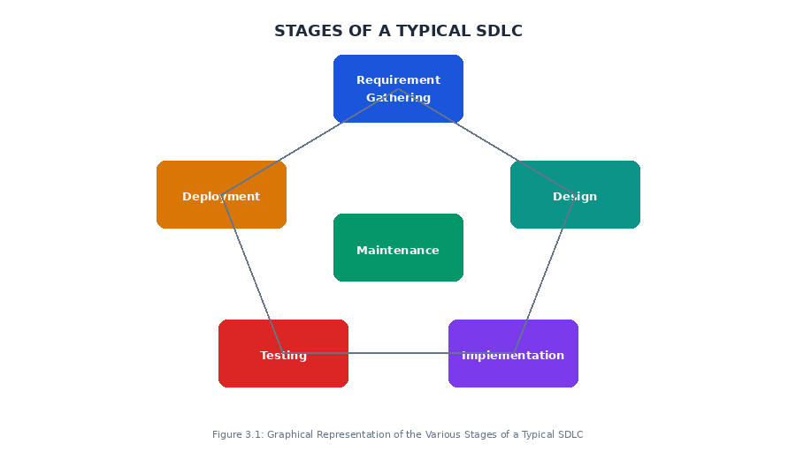
Figure 3.1: Graphical Representation of the Various Stages of a Typical SDLC

3.2.1 SDLC ACTIVITIES IN RELATION TO OUR PROJECT
Software life cycle models describe phases of the software cycle and the order in which those phases are executed. Each phase produces deliverables required by the next phase in the life cycle. Requirements are translated into design. Code is produced according to the design which is called the development phase. After coding and development, the testing verifies the deliverable of the implementation phase against requirements.
- Requirement gathering and analysis: The requirements for SecureScan were gathered through a systematic review of the document fraud problem in Cameroonian institutions, interviews with target users, and analysis of the limitations of existing forensic tools. The key requirements identified were: multi-layer forensic analysis, PDF and image support, downloadable forensic certificates, user authentication, and a reference hash template database.
A Requirement Specification document was created which serves as a guideline for the next phase of the model. The testing team follows the Software Testing Life Cycle and starts the Test Planning phase after the requirements analysis is completed.
- Design: In this phase the system and software design were prepared from the requirement specifications studied in the first phase. The system design for SecureScan specifies the four-layer architecture (frontend, backend, database, forensic engine), the database schema, the REST API endpoint structure, the three forensic analysis pipelines, and the risk scoring framework.
- Implementation / Coding: On receiving the system design documents, the work was divided into modules and actual coding was started. The backend forensic engine modules, the FastAPI REST API, the PostgreSQL database, and the Next.js frontend were all implemented in sequence. This is the main focus for the developer and represents the longest phase of the software development life cycle.
- Testing: After the code was developed it was tested against the requirements to make sure that the product was actually solving the needs identified during the requirements phase. Testing was conducted using Swagger UI for API endpoint validation, a Python test script for forensic engine validation, and manual end-to-end testing in the browser.
- Deployment: After successful testing the product is delivered and deployed for use. SecureScan is designed for deployment on Railway.app (backend) and Vercel (frontend), both free hosting platforms accessible to Cameroonian institutions.
- Maintenance: Once the users start using the developed system the actual problems come up and need to be solved from time to time. The modular architecture of SecureScan ensures that individual components can be updated or replaced without affecting the rest of the system.

3.3 SOFTWARE DEVELOPMENT PARADIGM
The software development paradigm helped me to select a strategy to develop the software. A software development paradigm has its own set of tools, methods and procedures, which are expressed clearly and defines the software development life cycle. A few of software development paradigms or process models are defined as follows:

3.3.1 WATERFALL MODEL
Waterfall approach was one of the first SDLC models to be used widely in Software Engineering to ensure the success of the project. In the Waterfall approach, the whole process of software development is divided into separate phases. In the Waterfall model, typically, the outcome of one phase acts as the input for the next phase sequentially. The major disadvantage of this model is that once the application is in the testing stage, it is very difficult to go back and change something that was not well-thought-out in the concept stage.

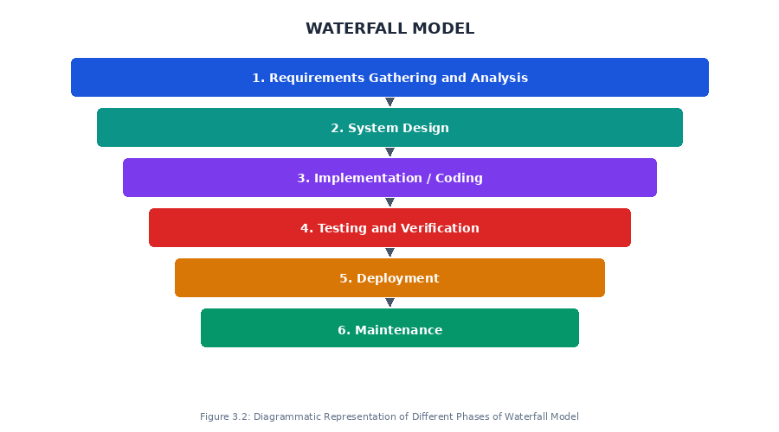
Figure 3.2: Diagrammatic Representation of Different Phases of Waterfall Model

3.3.2 ITERATIVE MODEL DESIGN
Iterative process starts with a simple implementation of a subset of the software requirements and iteratively enhances the evolving versions until the full system is implemented. At each iteration, design modifications are made and new functional capabilities are added. The basic idea behind this method is to develop a system through repeated cycles (iterative) and in smaller portions at a time (incremental).

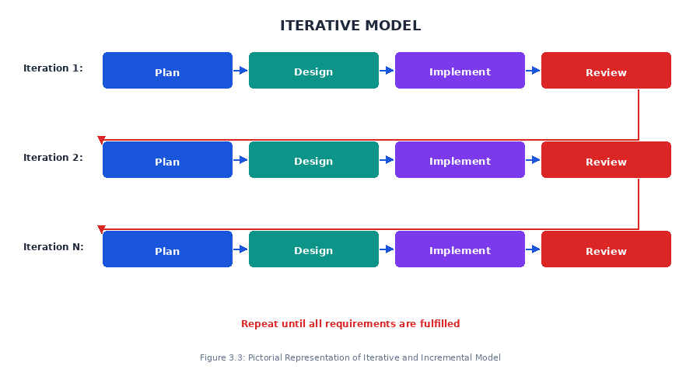
Figure 3.3: Pictorial Representation of Iterative and Incremental Model
3.3.3 SPIRAL MODEL DESIGN
The spiral model has four phases. A software project repeatedly passes through these phases in iterations called Spirals. The four phases are: Planning, Risk Analysis, Engineering, and Evaluation. The spiral model is particularly suitable for large, complex, and high-risk projects where requirements may change during development.

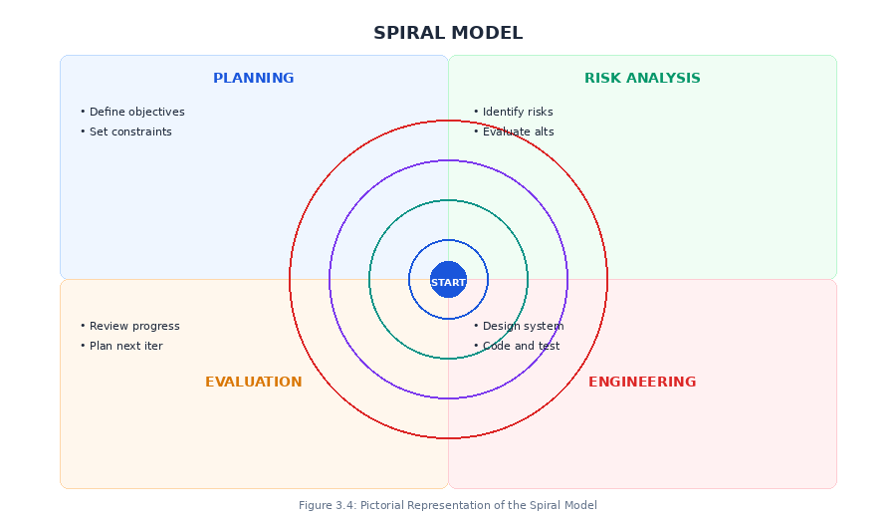
Figure 3.4: Pictorial Representation of the Spiral Model

3.3.4 V-MODEL DESIGN

Under the V-Model, the corresponding testing phase of the development phase is planned in parallel. So, there are Verification phases on one side of the V and Validation phases on the other side. Coding phase joins the two sides of the V-Model. This model is particularly useful when requirements are clearly defined and there is no ambiguity.

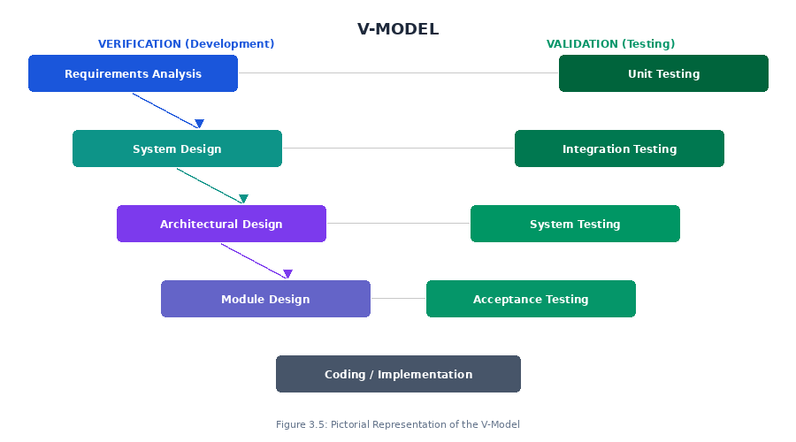
Figure 3.5: Pictorial Representation of the V-Model

3.3.5 BIG BANG MODEL
A bit of an anomaly among SDLC methodologies, the Big Bang model follows no specific process, and very little time is spent on planning. The majority of resources are thrown toward development, and even the client may not have a solid grasp of the requirements. This is one of the SDLC methodologies typically used for small projects with only one or two software engineers.

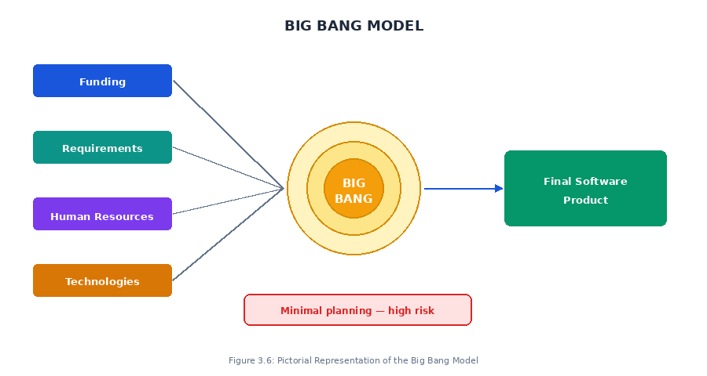
Figure 3.6: Pictorial Representation of the Big Bang Model

3.3.6 BEST SUITED MODEL
After studying these models, the model which I think is best suited for the development of SecureScan is the Design Science Research (DSR) methodology combined with elements of the Iterative model. It has the following advantages:
- Produces a tangible artefact — the SecureScan web application — as the primary research output.
- Allows iterative refinement of each forensic engine module based on test results.
- Supports evaluation of the artefact against defined performance criteria.
- Aligns the development process directly with the five specific objectives of the research.
- Software is produced early in the research cycle, allowing testing and feedback before final evaluation.

3.4 MODULES OF THE PROJECT (SECURESCAN)
Modules represent the different tasks which the application can perform. SecureScan has different aspects that work together to deliver a complete forensic document verification service. The main modules of SecureScan are: the User Authentication Module, the Document Upload and Scan Module, the Metadata Analysis Engine, the Error Level Analysis Engine, the Hash Verification Engine, the Risk Scoring Module, and the Forensic Certificate Generator.

3.4.1 AUTHENTICATION MODULE
Authentication is the process of determining whether someone or something is, in fact, who or what it declares itself to be. Authentication technology provides access control for the system by checking to see if a user's credentials match the credentials in a database of authorized users or in a data authentication server.
In SecureScan, there is a login interface demanding the user for credentials (email address and password). The credentials are verified against the stored bcrypt hash in the PostgreSQL database. If the credentials are valid, the system generates a signed JWT access token. In case there is failure in the authentication process, the software displays a clear error message and asks the user to try again. A forgot password feature is also provided, which sends a 6-digit reset code to the user's registered email address.

3.4.2 DOCUMENT UPLOAD AND SCAN MODULE
The Document Upload and Scan Module is the central module of SecureScan. It manages the receipt of uploaded documents from authenticated users and coordinates the execution of all three forensic analysis layers. A drag-and-drop upload interface and a camera capture interface are provided. The module accepts PDF, JPEG, and PNG format documents. A document type selector allows the user to specify the nature of the document being submitted — Official PDF, Scanned Copy, Phone Photo, or Downloaded File — so that the risk scoring engine can apply context-aware analysis rules appropriate to that document type. After receiving the uploaded file, the module invokes the three forensic engines in sequence, computes a context-aware risk score, saves the scan record to PostgreSQL, and returns the full forensic results to the frontend.

3.4.3 METADATA ANALYSIS ENGINE MODULE
The Metadata Analysis Engine implements the first forensic layer of SecureScan. Every digital document embeds metadata that records its creation history, modification history, and the software applications used in its production. This module uses ExifTool and PyMuPDF to extract and analyse the metadata of submitted documents and flag anomalies according to eight defined forensic rules (MD-01 through MD-08).

3.4.4 ERROR LEVEL ANALYSIS ENGINE MODULE
The Error Level Analysis Engine implements the second forensic layer of SecureScan. JPEG compression introduces characteristic artefact patterns that differ between original and modified image regions. This module exploits these differential compression signatures to produce a Tamper Heatmap image and a numerical ELA suspicion score using Python's Pillow library.

3.4.5 HASH VERIFICATION ENGINE MODULE
The Hash Verification Engine implements the third forensic layer of SecureScan. This module computes the SHA-256 cryptographic hash fingerprint of the submitted document and compares it against a database of hash values derived from authenticated reference templates. Three outcomes are possible: MATCH, NO_MATCH, and NOT_IN_DATABASE.

3.4.6 FORENSIC CERTIFICATE GENERATOR MODULE
The Forensic Certificate Generator Module produces downloadable PDF forensic certificates for each completed scan. The certificate is generated using Python's ReportLab library and contains seven sections: the certificate header with scan reference and date; document information including filename, format, file size, and SHA-256 hash; Layer 1 metadata findings with all detected anomalies listed by rule ID and severity; Layer 2 ELA score, suspicion flag, and a plain-English interpretation of the error level; Layer 3 hash match status, matched institution name if applicable, and a plain-English interpretation of the hash result; the overall risk assessment showing the risk score, risk verdict, and recommended action; and a legal disclaimer. All interpretation fields are automatically populated with context-specific text based on the forensic findings, ensuring that no field is left empty in the generated certificate.

3.5 ARCHITECTURAL DESCRIPTION OF THIS PROJECT
Architecture is the structure and organization of a computer's hardware or system software, but in our case, it is the structural organization of our software. Here we present the flow of data in the entire system. Subsequently, we shall present the flow in each module.

3.5.1 ARCHITECTURAL DESCRIPTION OF THE SYSTEM
SecureScan is implemented as a full-stack web application organized into four principal architectural layers. The frontend layer provides the user-facing interface for document upload, results display, user authentication, and forensic report download. The backend layer receives uploaded documents and orchestrates the three forensic analysis modules. The database layer stores user account data, scan history records, and the reference hash template database. The forensic engine layer comprises three independent modules invoked by the backend on each submitted document.

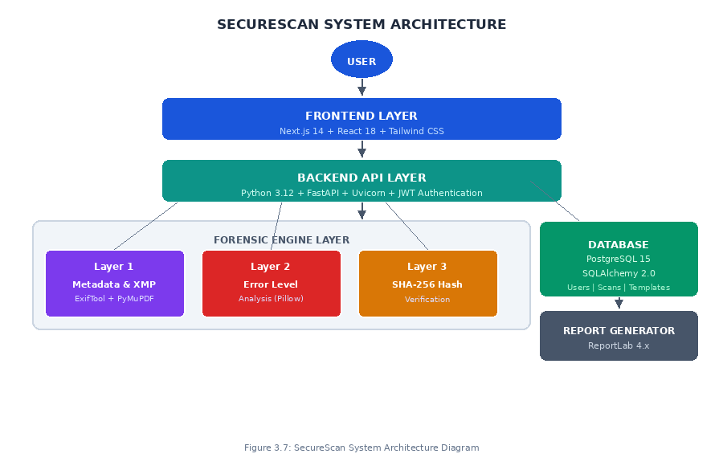
Figure 3.7: SecureScan System Architecture Diagram

Table 3.1: SecureScan System Architecture Summary
Layer | Technology Used | Responsibility
Frontend | Next.js 14, React.js 18, Tailwind CSS 3 | User interface: document upload, results dashboard, forensic certificate download, login and registration
Backend API | Python 3.12, FastAPI, Uvicorn | REST API endpoints, forensic pipeline orchestration, JWT authentication, PDF report generation
Database | PostgreSQL 15, SQLAlchemy 2.0 ORM | User accounts, scan records, SHA-256 reference hash template database
Metadata Engine | ExifTool 12.x, PyMuPDF 1.23 | PDF and image metadata and XMP extraction and anomaly detection
ELA Engine | Pillow 10.x | JPEG re-compression differential analysis and Tamper Heatmap generation
Hash Engine | Python hashlib (SHA-256) | SHA-256 fingerprint computation and reference database comparison
Report Generator | ReportLab 4.x | Structured downloadable PDF forensic certificate generation
Authentication | python-jose (JWT), passlib (bcrypt) | Stateless JWT-based user authentication and authorization
Source: Researcher's own design (2025)

3.6 ANALYSIS METHODS
SecureScan is expected to have a database for storing forensic scan records and user information, the ability to capture and process document files submitted by users, to perform forensic analysis on submitted documents, to generate forensic reports, and security to protect user data from unauthorized access. The methods used in designing and realizing the application will be explained in detail.
This method generally falls under two broad categories. They are the object-oriented methods and the functional methods. Below, the various types of methods are going to be explained including their advantages and disadvantages, and the model used in designing our application will be justified.

3.6.1 OBJECT-ORIENTED METHOD
The Object-Oriented designing approach has use-cases as its central point. The whole of use-cases represents the behaviour in the modelling stage. A model is an abstract representation of reality. It enables one to reduce the complexity of a phenomenon by eliminating details which do not influence its behaviour significantly. Each model describes the internal structure and their objects, their dynamics when the actors make requirements and the system supplies results.
Some examples of Object-Oriented methods are: OMT, UML.
- OBJECT MODELLING TECHNIQUE (OMT)
Object Modelling Technique (OMT) is an Object-Oriented modelling technique. It is a modelling method that capitalizes on entity-relationship modelling and techniques that chart on different aspects of the system such as its statistics, its dynamics and its functionality. The purposes of modelling according to Rumbaugh et al. (1991) are:
- Testing physical entities before building them (simulation),
- Communication with customers,
- Visualization (alternative presentation of information), and
- Reduction of complexity.
- SOME LIMITATIONS OF OMT
- OMT's primary weakness is its lack of an explicit mechanism to capture timing constraints and real-time issues.
- OMT lacks a comprehensive architecture as it does not take into consideration the testing phase of the software development cycle.
- The role and use of data flow diagrams seem to detract from the object-oriented approach.
- The syntax of the model is not well defined. Sharing of model components among different models is not clear.

3.6.2 FUNCTIONAL METHOD
UML METHOD
The Unified Modeling Language (UML) is the preferred method used for the design of this work. UML is a general-purpose modelling language in the field of software engineering that is designed to provide a standard way to visualize the design of a system.

3.7 PREFERRED METHOD AND JUSTIFICATION
The preferred method used for the realization of this work is UML. Below is a brief history of UML and equally a justification of why it was chosen for the work.

3.7.1 BRIEF HISTORY OF UML
Identifiable object-oriented modelling languages began to appear between the mid-1970s and the late 1980s as various methodologists experimented with different approaches to object-oriented analysis and design. The number of identified modelling languages increased from less than 10 to more than 50 during the period between 1989 and 1994.
The development of UML began in late 1994 when Grady Booch and Jim Rumbaugh of Rational Software Corporation began their work on unifying the Booch and OMT methods. In the Fall of 1995, Ivar Jacobson and his Objectory company joined Rational and this unification effort, merging in the OOSE method.

3.7.2 REASONS FOR CHOOSING UML

The following points below are the reasons why we chose UML.
- The graphical nature of the language makes it much more intuitive to learn and use.
- UML can be used to model just about any type of application, running on any type and combination of hardware, operating system, programming language and network.
- UML makes it easy to focus discussions on the problem at hand while removing distractions.
- UML method is an effective communication support for documenting and modelling a system.
- The flexibility of UML makes it a more universal language than others.
- With UML the maintenance of the systems is easier than with the other methods.

3.8 MODELLING OF THE ENTIRE SYSTEM
Modelling is the act of representing something (usually on a smaller scale). In our case, we shall be representing the SecureScan forensic document verification system using UML diagrams. We shall use the two main modelling types of UML namely Static (or structural) view, which includes Class diagram, and the Dynamic (or behavioral) view, which includes Sequence diagram, Activity diagram, and Use Case diagram. There are fourteen diagrams in total as shown in the figure below.

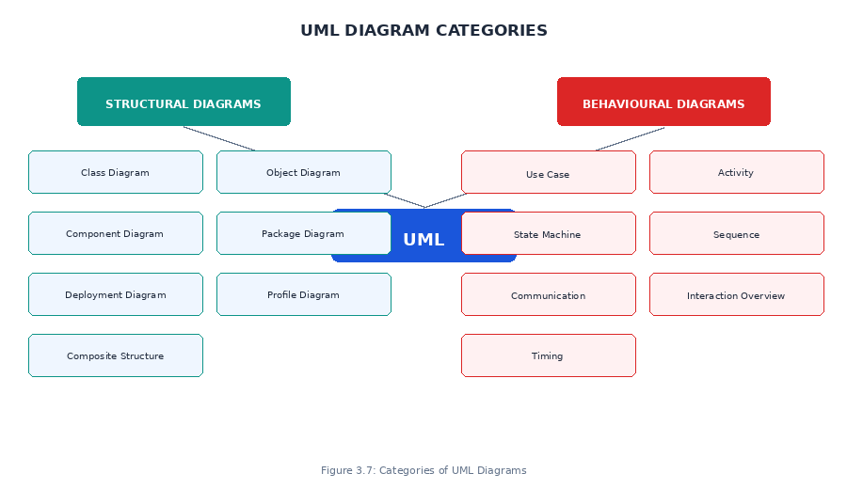
Figure 3.7: Categories of UML Diagrams

3.8.1 OVERVIEW OF THE FUNCTIONALITIES OF SECURESCAN
SecureScan is a web-based forensic document verification system designed to streamline the process of detecting document tampering and fabrication, thereby improving institutional security and enhancing the reliability of document-based decision-making. The key system functionalities of SecureScan are:

3.8.2 USER REGISTRATION AND LOGIN
- Users can register a new account by providing their full name, email address, and a password.
- Users can log in with their registered email and password to access the system.
- The system checks the credentials and generates a signed JWT access token if the credentials are valid.
- The system sends a 6-digit reset code to the user's email if they forget their password.

3.8.3 DOCUMENT UPLOAD AND FORENSIC SCAN
- Users upload a document (PDF, JPEG, or PNG format) using drag-and-drop or camera capture.
- The system verifies the file format and passes it through all three forensic analysis layers.
- If all layers complete successfully, the system computes a risk score and returns the verdict to the user.

3.8.4 FORENSIC RESULTS DISPLAY
- Users can view the complete forensic findings for each scan on the results dashboard.
- The system displays the risk score, risk verdict, metadata anomalies, ELA score, and hash match status.

3.8.5 FORENSIC CERTIFICATE DOWNLOAD
- Users can request a downloadable PDF forensic certificate for any completed scan.
- The system generates the certificate on demand and returns it as a downloadable PDF file.

3.8.6 SCAN HISTORY MANAGEMENT
- Users can view a complete list of all their previous scans, ordered from most recent to oldest.
- They can view the verdict and risk score of each past scan and download the corresponding certificate.

3.8.7 REFERENCE HASH TEMPLATE MANAGEMENT
- Administrator users can add authenticated document hash values to the reference template database.
- Administrators can view all registered templates and delete any that are no longer needed.

3.9 THE SECURESCAN SYSTEM
The system was broken down into seven sub-systems: User Authentication Manager, Document Upload Manager, Metadata Analysis Engine, Error Level Analysis Engine, Hash Verification Engine, Risk Scoring Module, and Forensic Certificate Generator.
- User Authentication Manager: Manages user accounts, creates user data such as full names, email addresses, user roles, and hashed passwords. It also manages security and user authorization using JWT tokens and bcrypt password hashing.
- Document Upload Manager: Manages the receipt of uploaded documents from authenticated users. It validates the file format, coordinates the invocation of all three forensic engines, and stores the completed scan record in the database.
- Metadata Analysis Engine: Invokes ExifTool and PyMuPDF to extract and analyse the metadata of submitted documents. It evaluates the extracted fields against eight forensic anomaly detection rules (MD-01 through MD-08).
- Error Level Analysis Engine: Implements the ELA algorithm using Python's Pillow library. It re-compresses the submitted image, computes the pixel-wise difference, generates a Tamper Heatmap, and computes the ELA suspicion score.
- Hash Verification Engine: Computes the SHA-256 hash fingerprint of the submitted document and queries the reference hash template database. It returns one of three outcomes: MATCH, NO_MATCH, or NOT_IN_DATABASE.
- Risk Scoring Module: Synthesizes the outputs of the three forensic layers into a single integer risk score (0 to 100) and maps it to a categorical risk verdict: AUTHENTIC, SUSPICIOUS, LIKELY FORGED, or FORGED.
- Forensic Certificate Generator: Generates a structured, multi-section PDF forensic certificate using the ReportLab library, recording all forensic findings and the overall risk verdict.
The design of the SecureScan system is shown below.

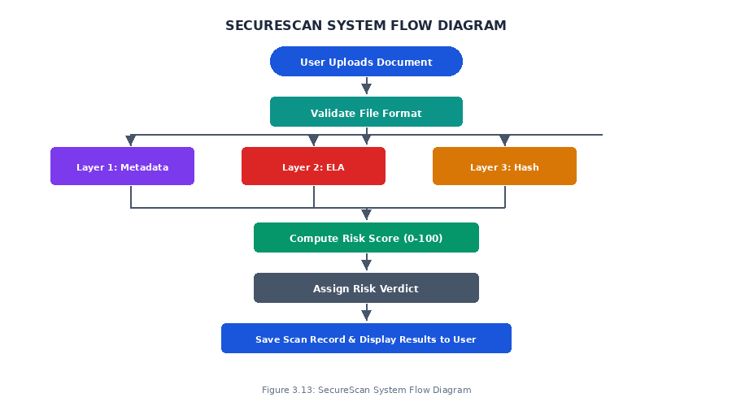
Figure 3.8: SecureScan System Flow Diagram

3.10 BEHAVIOUR DIAGRAM
Behavioural diagrams depict the behavioural features of a system or business process. They show the dynamic aspects of the system, describing how the system behaves and responds to different inputs over time.

3.10.1 ACTIVITY DIAGRAM
An activity diagram describes the business and operational step-by-step workflows of components in a system. An activity diagram shows the overall flow of control. The diagram below illustrates the complete flow of the SecureScan document scan process, from user login to the display of forensic results.

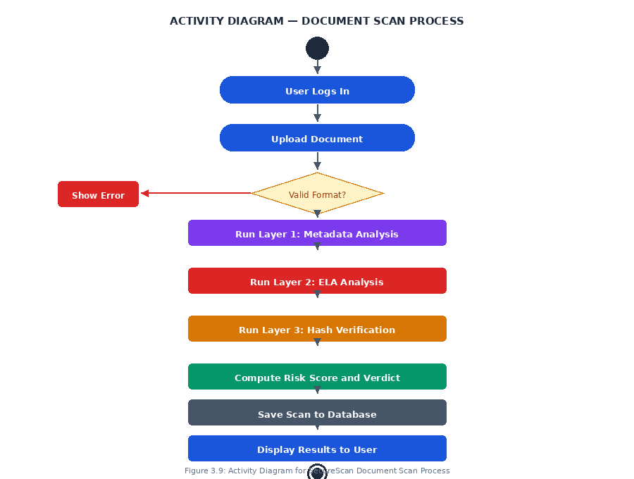
Figure 3.8: Activity Diagram for SecureScan Document Scan Process

3.10.2 USE CASE DIAGRAM
Use case diagrams are usually referred to as behaviour diagrams used to describe a set of actions (use cases) that some system should or can perform in collaboration with one or more external users of the system (actors). Each use case should provide some observable and valuable result to the actors or other stakeholders of the system. The main actors in SecureScan are the Regular User and the Administrator User.

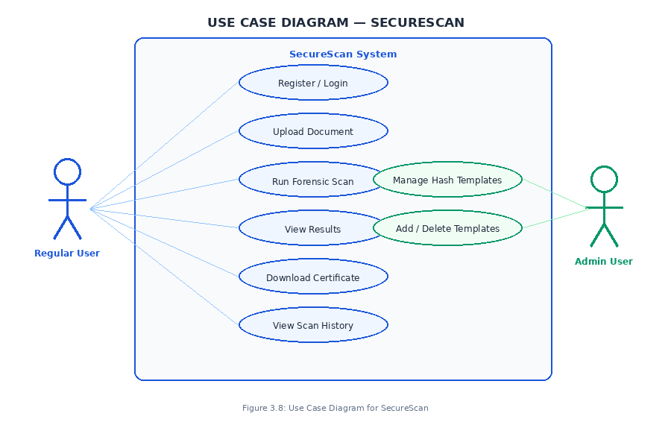
Figure 3.9: Use Case Diagram for SecureScan

3.10.3 SEQUENCE DIAGRAM
A sequence diagram shows object interactions arranged in time sequence. It depicts the objects and classes involved in the scenario and the sequence of messages exchanged between the objects needed to carry out the functionality of the scenario. The diagram below illustrates the interaction between system components during a complete document scan operation.

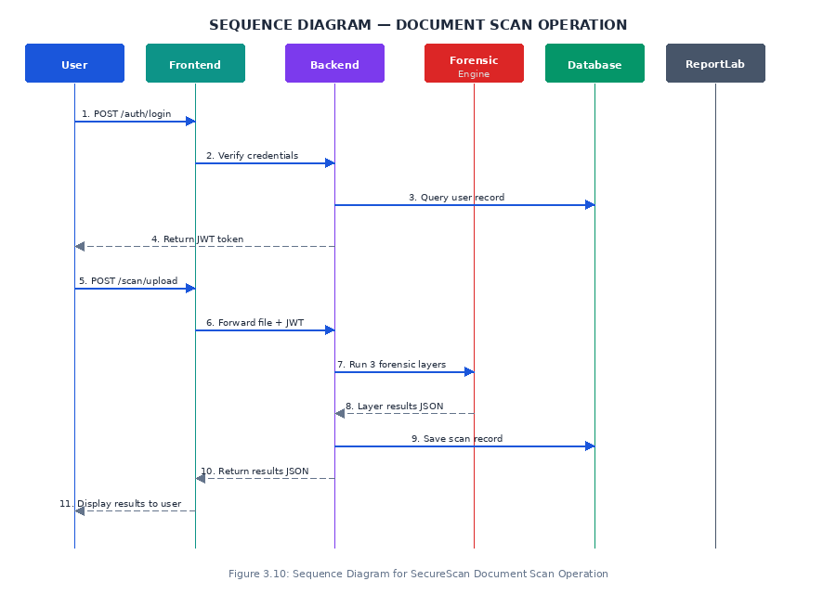
Figure 3.10: Sequence Diagram for SecureScan Document Scan Operation
3.10.4 CLASS DIAGRAM
A class diagram describes the system by visualizing the different types of objects within a system and the kinds of static relationships that exist among them. It also illustrates the operations and attributes of the classes. The main classes in SecureScan are: User, Scan, Hash Template, Forensic Engine, and Report Generator.
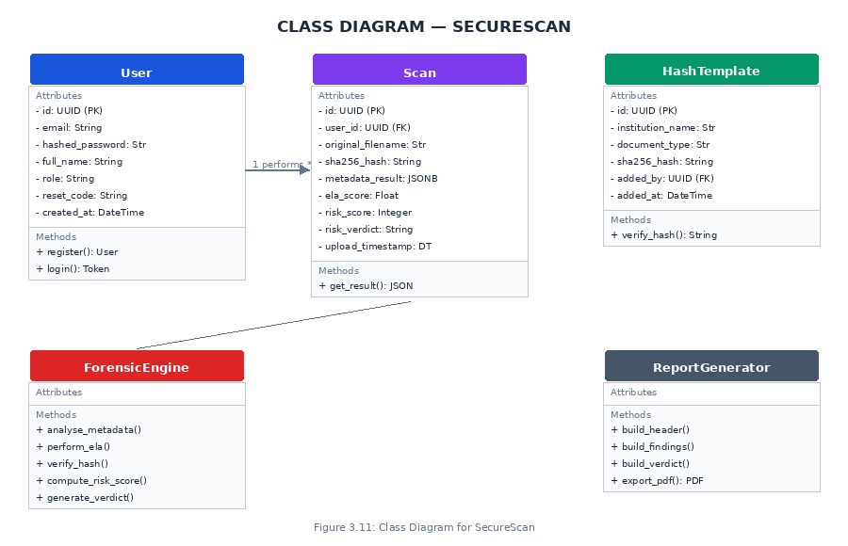

Figure 3.11: Class Diagram for SecureScan

3.11 TECHNOLOGIES AND TOOLS USED
Technology is the discipline dealing with the art or science of applying scientific knowledge to practical problems. In order to realize this project, the following tools and technologies were used.

3.11.1 HARDWARE
A Dell laptop with an Intel Core i5 processor, 8 GB RAM, and a 256 GB SSD running Windows 11 64-bit was used as the hardware requirement for the development and testing of the system. No specialized or laboratory-grade hardware was required, which is consistent with SecureScan's design objective of being developable and deployable on standard consumer-grade computing equipment available to Cameroonian institutions.

3.11.2 FRONT END TECHNOLOGIES
- Next.js 14: Next.js is a React-based full-stack web framework that provides server-side rendering, file-based routing, and built-in API routes. It was selected over plain React and Vue.js because it provides routing, server-side rendering, and API route capabilities natively without requiring additional configuration libraries.
- React.js 18: React.js is the core UI library upon which Next.js is built. React 18 introduces concurrent rendering features that improve UI responsiveness during heavy operations such as file uploads and API response processing.
- Tailwind CSS 3: Tailwind CSS is a utility-first CSS framework that applies styling through predefined class names directly in the HTML markup. It was selected over Bootstrap (which produces visually generic interfaces) and Material UI (which enforces Google's Material Design aesthetic).
- Axios: Axios is an HTTP client used for making API requests from the Next.js frontend to the FastAPI backend. It was selected over the browser's native Fetch API because it supports request interceptors for automatic JWT header attachment, automatic JSON parsing, and more informative error objects.
- React Dropzone: React Dropzone is a drag-and-drop file upload component that provides a professional upload interface with file type validation and camera capture support, significantly improving user experience over a plain HTML file input.

Table 3.2: Frontend Technologies Summary
Technology | Version | Purpose | Why Selected Over Alternatives
Next.js | 14.x | Full-stack framework | File-based routing, SSR; superior to plain React and Vue.js
React.js | 18.x | Core UI library | Required by Next.js; concurrent rendering improves responsiveness
Tailwind CSS | 3.x | CSS styling | Utility-first; superior to Bootstrap (generic) and Material UI (Google aesthetic)
Axios | 1.6+ | API communication | Request interceptors for JWT; auto JSON parsing; better errors than Fetch API
React Dropzone | 14.x | File upload | Professional drag-and-drop with validation; better UX than plain file input
Source: Researcher's own selection and justification (2025)

3.11.3 BACK END TECHNOLOGIES
- Python 3.12: Python 3.12 was selected as the backend programming language because all three forensic libraries central to SecureScan — PyMuPDF, Pillow, and ExifTool subprocess integration — have mature, well-maintained Python bindings that do not exist in comparable quality for other languages.
- FastAPI: FastAPI is a modern, high-performance Python web framework for building REST APIs. It was selected over Flask (no native async support) and Django REST Framework (heavyweight) because it automatically generates interactive API documentation and provides a built-in dependency injection system for JWT authentication.
- PyMuPDF (fitz): PyMuPDF provides Python-level access to the internal structure of PDF documents including embedded image extraction and incremental update detection. It was selected over PyPDF2 (no image extraction) and pdfplumber (designed for text extraction, not forensic analysis).
- Pillow: Pillow is the standard Python image processing library used for JPEG re-compression in the ELA module. It was selected because its BytesIO buffer support provides the cleanest in-memory JPEG re-compression capability needed for ELA.
- SQLAlchemy 2.0: SQLAlchemy is the ORM used for all PostgreSQL database interactions. It prevents SQL injection vulnerabilities and produces more readable code than raw SQL queries.
- python-jose: python-jose is the JWT library used for user authentication. It integrates cleanly with FastAPI's dependency injection pattern and supports a broad range of cryptographic algorithms.
- passlib with bcrypt: passlib is used for password hashing. bcrypt was chosen because its configurable work factor makes brute-force attacks computationally expensive.
- ReportLab: ReportLab is used for the programmatic generation of PDF forensic certificates. It was selected over WeasyPrint (HTML engine overhead) and fpdf2 (limited table capabilities) because it provides the most precise programmatic control over PDF layout.

Table 3.3: Backend Technologies Summary
Technology | Version | Purpose | Why Selected Over Alternatives
Python | 3.12.x | Backend language | Only language with mature bindings for all three forensic libraries
FastAPI | 0.111+ | REST API framework | Auto-generates docs; native async; JWT injection; superior to Flask and Django DRF
PyMuPDF | 1.23+ | PDF structural analysis | Only library with embedded image extraction and incremental update detection
Pillow | 10.x | Image processing for ELA | Standard Python image library; BytesIO buffer for in-memory JPEG re-compression
SQLAlchemy | 2.0+ | Database ORM | Prevents SQL injection; cleaner than raw psycopg2
python-jose | 3.3+ | JWT authentication | Cleaner FastAPI integration than PyJWT; broader algorithm support
passlib[bcrypt] | 1.7+ | Password hashing | bcrypt work factor resists brute-force attacks
ReportLab | 4.x | PDF certificate generation | Most mature Python PDF library; precise layout control
Source: Researcher's own selection and justification (2025)

3.11.4 DATABASE
- PostgreSQL 15: PostgreSQL is the relational database management system used for SecureScan. It was selected over MySQL because it natively supports JSONB column type for storing forensic analysis results, and over SQLite because SQLite does not support concurrent writes from multiple users.

3.11.5 VISUAL STUDIO CODE
Visual Studio Code is a code editor used for writing and editing code of multiple programming languages. It was chosen as the primary development environment for SecureScan because of its free availability, its native support for both Python and JavaScript/TypeScript within a single workspace, and its rich ecosystem of extensions for code completion, linting, and debugging.

3.11.6 GIT AND GITHUB
Git is the version control system used for SecureScan's development. Git allows the researcher to track every change made to the codebase, revert to earlier working versions when errors are introduced, and maintain a complete history of the development process. All code was committed to a remote GitHub repository at github.com/Precious325/SecureScan.

3.11.7 EXIFTOOL
ExifTool is an open-source command-line application for reading and editing metadata in a wide variety of digital file formats including PDF, JPEG, PNG, TIFF, and many others. In SecureScan, ExifTool is invoked as a Python subprocess to extract the complete metadata of each uploaded document. It was selected because it is the most comprehensive metadata extraction tool available, supporting over 200 file formats.

3.12 RISK SCORING FRAMEWORK
The outputs of the three forensic layers are synthesized into a single integer Risk Score ranging from 0 to 100 and a categorical Risk Verdict by the Risk Scoring Module. SecureScan implements a context-aware risk scoring system that adjusts the weight of forensic anomalies based on the document type selected by the user. This prevents false positives on legitimate documents that naturally exhibit certain metadata characteristics due to their capture or transfer method.
The four document types and their scoring adjustments are:
- Official PDF: All forensic rules applied at full weight. This is the strictest scoring mode used for officially issued PDF documents downloaded directly from institutional sources.
- Scanned Copy: Metadata rules MD-03, MD-04, MD-06 and MD-07 are skipped since scanning software naturally modifies metadata. ELA flagging threshold is raised to 0.25 to account for scanner compression artefacts.
- Phone Photo: Metadata rules MD-06 and MD-07 are skipped since phone cameras embed EXIF camera data. ELA flagging threshold is raised to 0.35 since JPEG phone photos naturally have higher compression artefacts.
- Downloaded File: Metadata rules MD-04, MD-06 and MD-07 are skipped since file transfer applications such as WhatsApp and email strip metadata during transmission.

Table 3.4: Risk Score Computation Weighting Scheme
Component | Condition | Points Added
Layer 1 — Metadata | CRITICAL severity anomaly (e.g. ModDate before CreationDate) | +30 per critical anomaly
Layer 1 — Metadata | HIGH severity anomaly (e.g. missing metadata, Photoshop in EXIF) | +15 per high anomaly
Layer 1 — Metadata | MEDIUM severity anomaly (e.g. Creator differs from Producer) | +8 per medium anomaly
Layer 1 — Metadata | LOW severity anomaly (e.g. PDF editor in Producer field) | +3 per low anomaly
Layer 2 — ELA | ELA suspicion flag = True (threshold varies by document type) | +10 to +25 points
Layer 3 — Hash | Hash result = NO_MATCH (document differs from template) | +40 points
Layer 3 — Hash | Hash result = MATCH (document matches template) | -10 points
Layer 3 — Hash | Hash result = NOT_IN_DATABASE | 0 points (neutral)
Source: Researcher's own risk weighting design (2025)
The total Risk Score is then mapped to a categorical Risk Verdict as shown in the figure below.

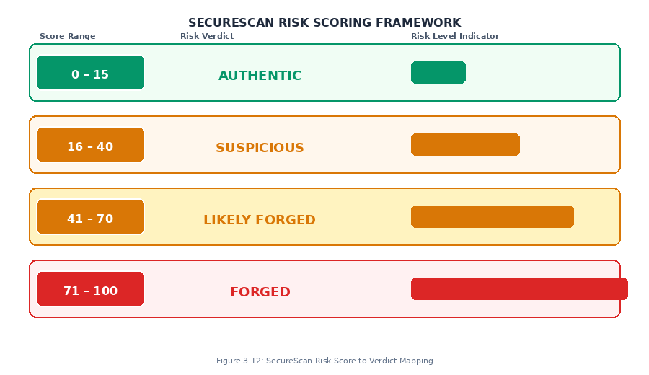
Figure 3.12: SecureScan Risk Score to Verdict Mapping

3.13 TEST DATASET AND LOCAL CONTEXT VALIDATION

To ensure the system's forensic relevance in the Cameroonian institutional context, the evaluation dataset is composed entirely of locally significant document types. The dataset contains both authentic specimens and deliberately forged versions created by the researcher for testing purposes only. All authentic documents containing personal identifying information are anonymized before use in this research.

Table 3.4: SecureScan Evaluation Test Dataset
Document | Type | Risk Score | Verdict | Hash Result
UBa Semester Result Slip | Authentic | 0 / 100 | AUTHENTIC | MATCH
National Identity Card (CNI) | Authentic | 0 / 100 | AUTHENTIC | MATCH
Birth Certificate (phone photo) | Authentic | 20 / 100 | SUSPICIOUS | MATCH
GCE Results Slip (phone photo) | Authentic | 20 / 100 | SUSPICIOUS | MATCH
Edited Result Slip (PDF→Word→PDF) | Forged | 70 / 100 | LIKELY FORGED | NO_MATCH
Converted Result Slip (forged) | Forged | 55 / 100 | LIKELY FORGED | NO_MATCH
Source: Researcher's own test dataset — 6 Cameroonian institutional documents (2025). Additional documents will be added as testing continues.

3.14 EVALUATION METHODOLOGY

3.14.1 FORENSIC PERFORMANCE EVALUATION
The forensic performance of SecureScan is evaluated by submitting all eighty documents in the test dataset to the system and recording the Risk Verdict assigned to each. The following standard binary classification metrics are computed: True Positive (TP), True Negative (TN), False Positive (FP), and False Negative (FN). From these counts, Detection Accuracy, False Positive Rate, False Negative Rate, Precision, Recall, and F1-Score are computed. Processing latency is also measured for each scan.

3.14.2 USABILITY EVALUATION
The usability of SecureScan is evaluated through a structured evaluation exercise with thirteen participants drawn from three target user groups: five human resource professionals, five academic administrators, and three legal practitioners, recruited through convenience sampling from organizations in the North West Region of Cameroon. Each participant performs three standardized tasks. After completing the tasks, each participant completes the System Usability Scale (SUS) — a validated ten-item questionnaire producing a composite usability score from 0 to 100 (Brooke, 1996).

REFERENCES
Accenture. (2019). Compliance risk study: Managing the cost of compliance. Accenture Financial Services.
Adobe Systems Incorporated. (2008). PDF reference: Adobe portable document format version 1.7 (6th ed.). Adobe Press.
Association of Certified Fraud Examiners. (2022). Report to the nations: 2022 global study on occupational fraud and abuse. ACFE. Retrieved from https://www.acfe.com/report-to-the-nations/2022/
Carrier, B. (2003). Defining digital forensic examination and analysis tools using abstraction layers. International Journal of Digital Evidence, 1(4), 1-12.
Casey, E. (2011). Digital evidence and computer crime: Forensic science, computers and the internet (3rd ed.). Academic Press.
Christlein, V., Riess, C., Jordan, J., Riess, C., & Angelopoulou, E. (2012). An evaluation of popular copy-move forgery detection approaches. IEEE Transactions on Information Forensics and Security, 7(6), 1841-1854. doi: 10.1109/TIFS.2012.2218597
Coalition Against Insurance Fraud. (2022). The fraud landscape. Retrieved from https://insurancefraud.org/fraud-stats/
Eaton, S. E. (2020). Academic integrity during COVID-19: Reflections from the education sector. International Studies in Educational Administration, 48(1), 30-35.
Farid, H. (2016). Photo forensics. MIT Press.
Ferrara, P., Bianchi, T., De Rosa, A., & Piva, A. (2012). Image forgery localization via fine-grained analysis of CFA artifacts. IEEE Transactions on Information Forensics and Security, 7(5), 1566-1577. doi: 10.1109/TIFS.2012.2202227
Garfinkel, S. L. (2010). Digital forensics research: The next 10 years. Digital Investigation, 7(S1), S64-S73. doi: 10.1016/j.diin.2010.05.009
Garfinkel, S., Farrell, P., Roussev, V., & Dinolt, G. (2009). Bringing science to digital forensics with standardized forensic corpora. Digital Investigation, 6(S1), S2-S11.
Gloe, T., & Bohme, R. (2010). The Dresden image database for benchmarking digital image forensics. Proceedings of the ACM Symposium on Applied Computing (SAC), 1584-1590.
Hao, H., Kelley, A., & Donoho, D. (2011). XMP metadata forensics for digital document authentication. Journal of Digital Forensics, Security and Law, 6(2), 17-34.
Harvey, P. (2003). ExifTool: Read, write and edit meta information. Retrieved from https://exiftool.org/
HireRight. (2020). 2020 HireRight employment screening benchmark report. HireRight LLC.
Interpol. (2014). Document fraud — threats and global responses. Interpol General Secretariat.
Jones, M., Bradley, J., & Sakimura, N. (2015). JSON web token (JWT). RFC 7519. Internet Engineering Task Force. Retrieved from https://tools.ietf.org/html/rfc7519
Krawetz, N. (2007). A picture's worth: Digital image analysis and forensics. Black Hat Briefings. Retrieved from https://www.hackerfactor.com/papers/bh-usa-07-krawetz-wp.pdf
National Institute of Standards and Technology. (2015). Secure hash standard (SHS) (FIPS PUB 180-4). U.S. Department of Commerce. doi: 10.6028/NIST.FIPS.180-4
Pan, X., & Lyu, S. (2010). Region duplication detection using image feature matching. IEEE Transactions on Information Forensics and Security, 5(4), 857-867. doi: 10.1109/TIFS.2010.2078506
Ramírez, S. (2019). FastAPI: Modern, fast web framework for building APIs with Python 3.6+ based on standard Python type hints. Retrieved from https://fastapi.tiangolo.com/
Reith, M., Carr, C., & Gunsch, G. (2002). An examination of digital forensic models. International Journal of Digital Evidence, 1(3), 1-12.
Schneier, B. (1996). Applied cryptography: Protocols, algorithms, and source code in C (2nd ed.). John Wiley & Sons.
Stamm, M. C., Wu, M., & Liu, K. J. R. (2013). Information forensics: An overview of the first decade. IEEE Access, 1, 167-200. doi: 10.1109/ACCESS.2013.2260814
trinity652. (2024). DocAuth: An online document authentication portal [Software]. GitHub. Retrieved from https://github.com/trinity652/DocAuth
van Lanh, T., Chong, K. S., Emmanuel, S., & Kankanhalli, M. S. (2007). A survey on digital camera image forensic methods. IEEE International Conference on Multimedia and Expo, 16-19.
World Bank. (2022). Cameroon economic update: Digital technology for economic transformation. World Bank Group.

